Justin Fan, Fengwei Zhang, Vikas Advani Navani  
Project 3 Phase 2

This is an addition to the previous phase 1. The ROI data of the images in phase 1 will be used. The images are displayed at certain times. This adds the protocol for the server to send the image to the mobile devices at certain times.

In this phase we can view that we have 2 cases which we must take care of, each case has the description of time in seconds per image needing to be displayed according to the overall simulation time slot. There are several specifications that we need to consider such as the image size, bandwidth, delta, gamma and packet size. These must be taken Into account while designing the server for phase 2.

The transfer protocol from the server sends a request and the mobile responds with an acknowledgement. Once the server receives the acknowledgement, the image packet is sent. This is repeated until the entire image is sent.

Then the simulations between different bandwidths and image packet sizes are tested. The mobile and server are parameterized to take the image packet size and bandwidth. The simulation outputs the handshake protocols between the server and mobiles.

The mobiles output files with the total bytes stored on the device and the timestamp. This data is to be graphed and compared with each other. All of phase 1 description can be also taken into account in this one due to its continuation in this phase.

Because there is only 2400 gaze data points, the clock was reduced to a period of 0.1 seconds to allow for proper simulation. The resulting graphs and sample simulation from the simulation are shown below.

From the graphs, it can be concluded that storage of packets and tuples are inconsequential. Majority of the bytes are taken by the image and image packets. Packet size determines how many handshake events occur. The offset between the 2 mobile devices is too small to see at the time scale. The difference between the 2 mobile devices is a minimum of image size / bandwidth.

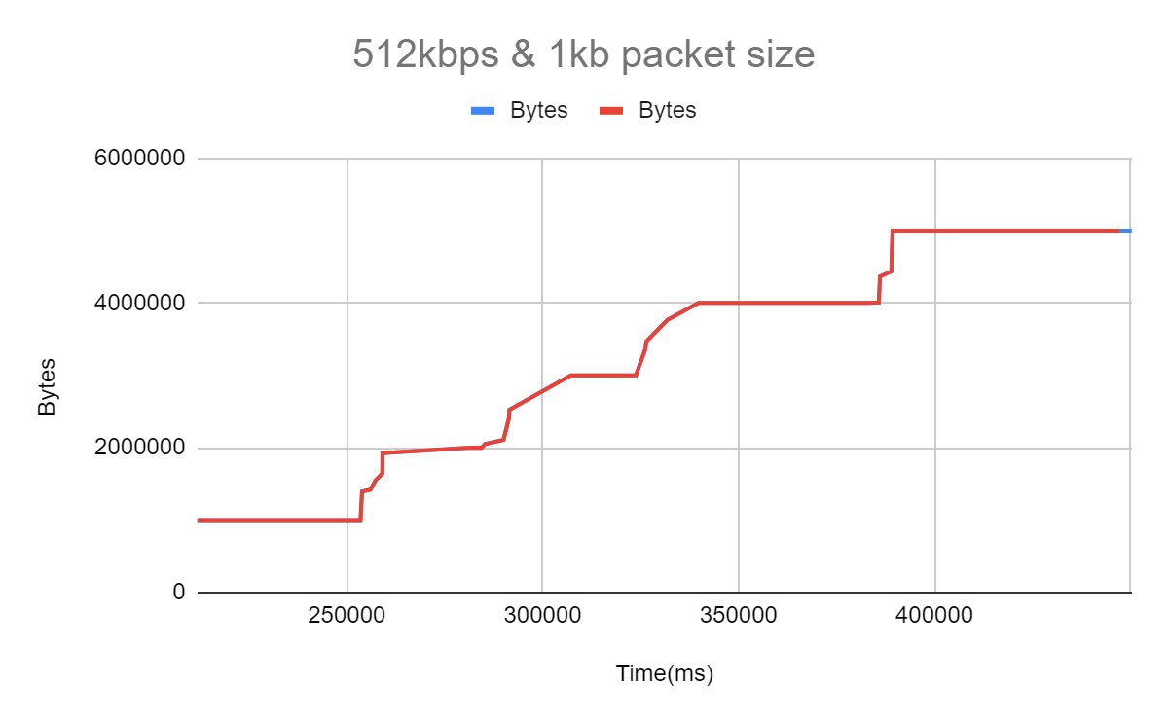

Figure 1. 512kbps & 1kb packet size

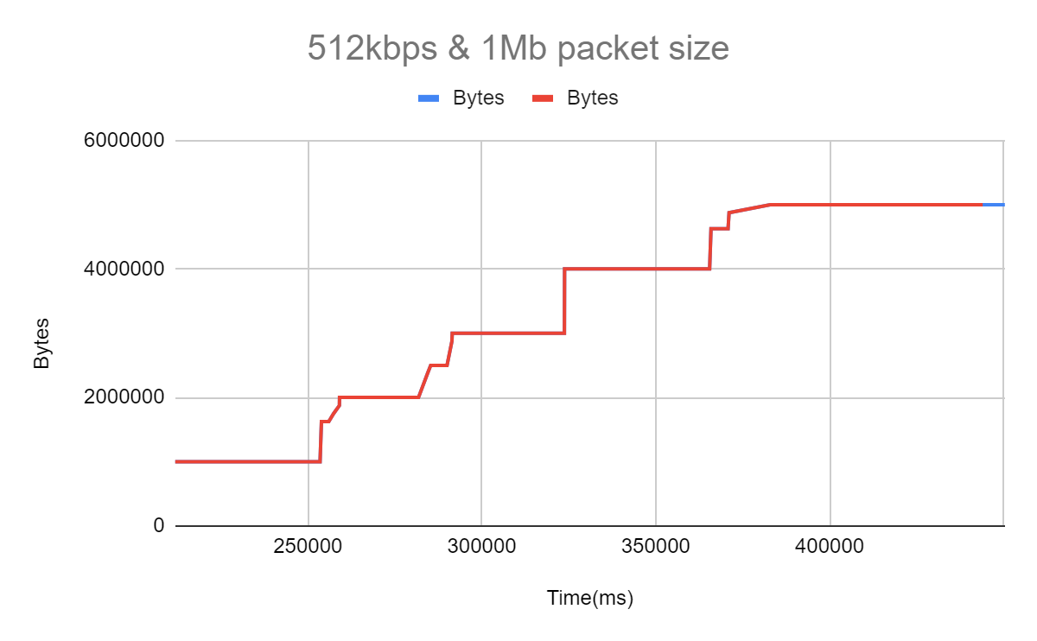

Figure 2. 512kbps & 1Mb packet size

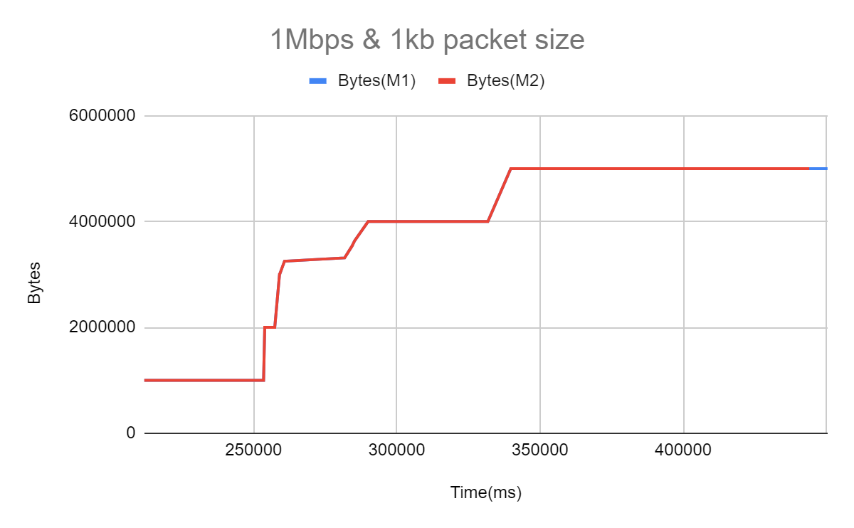

Figure 3. 1Mbps & 1kb packet size

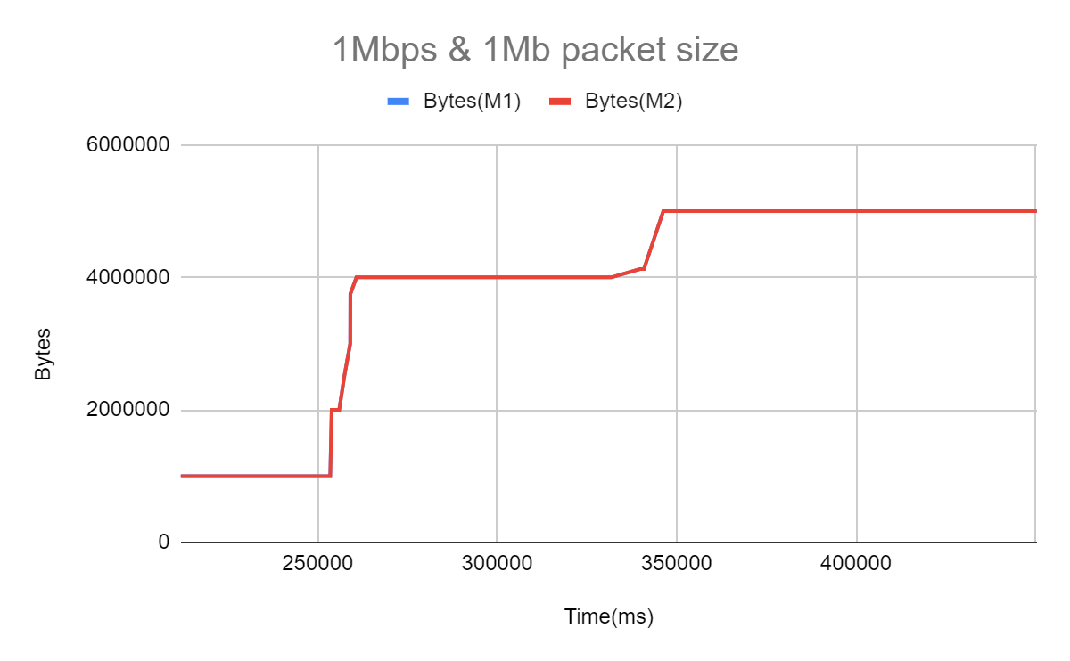

Figure 4. 1Mbps & 1Mb packet size

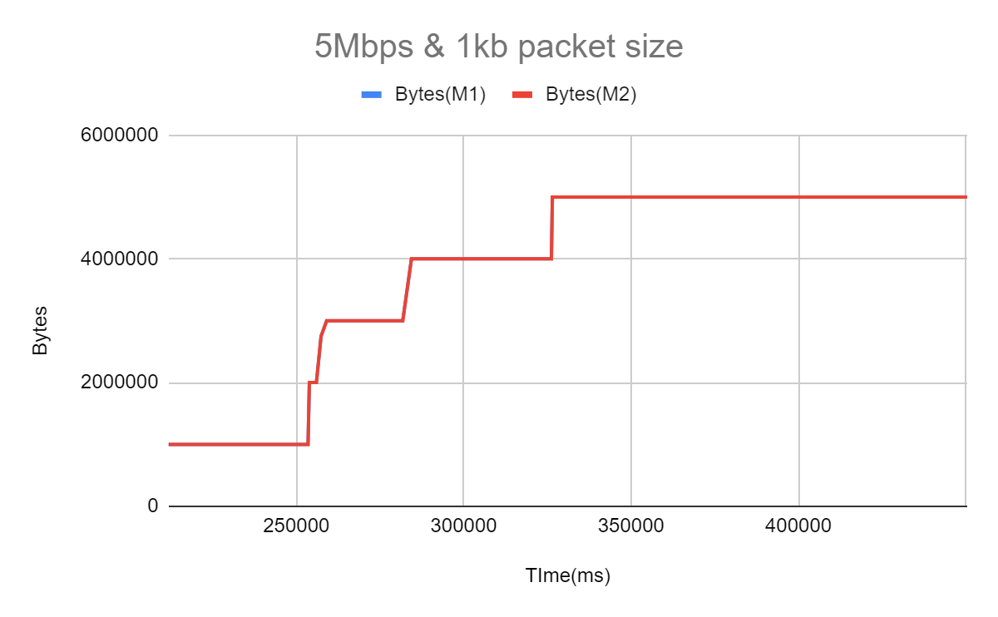

Figure 5. 5Mbps & 1kb packet size

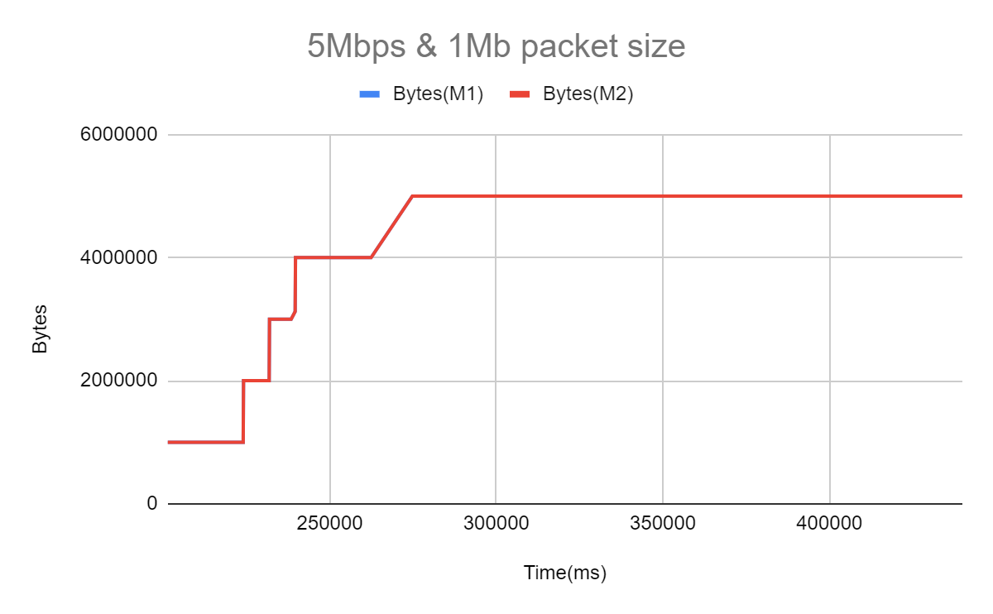

Figure 6. 5Mbps & 1Mb packet size

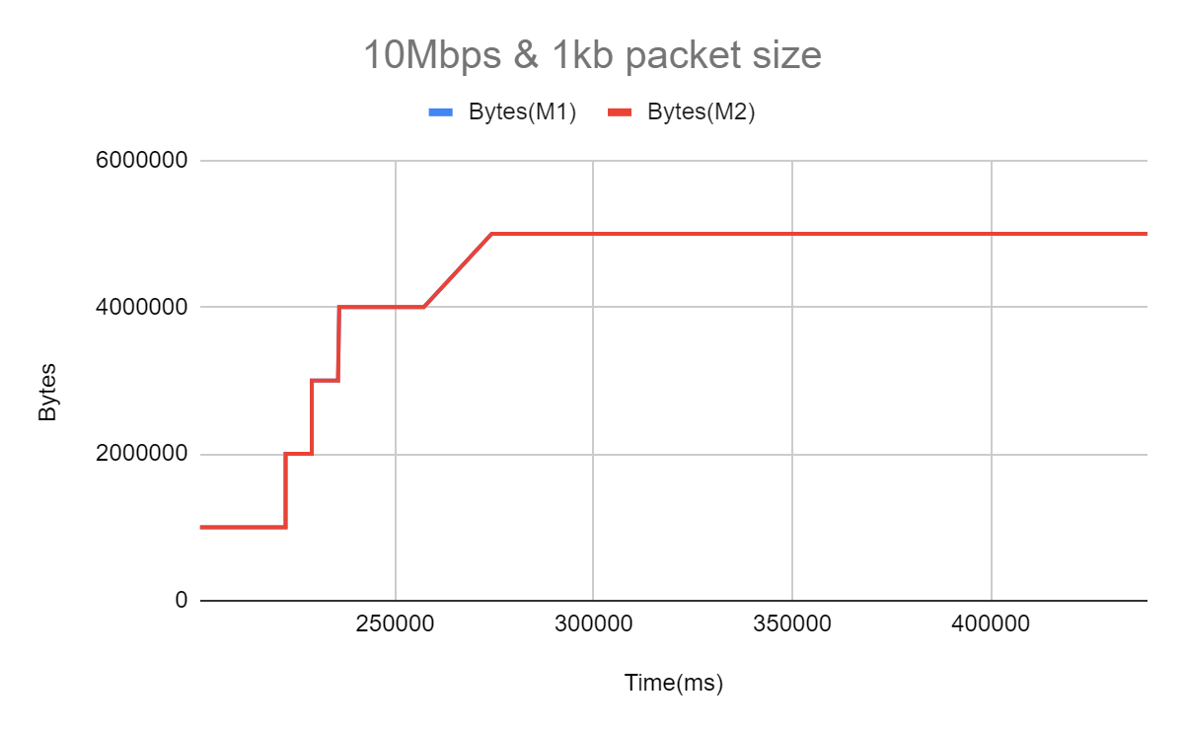

Figure 7. 10Mbps & 1kb packet size

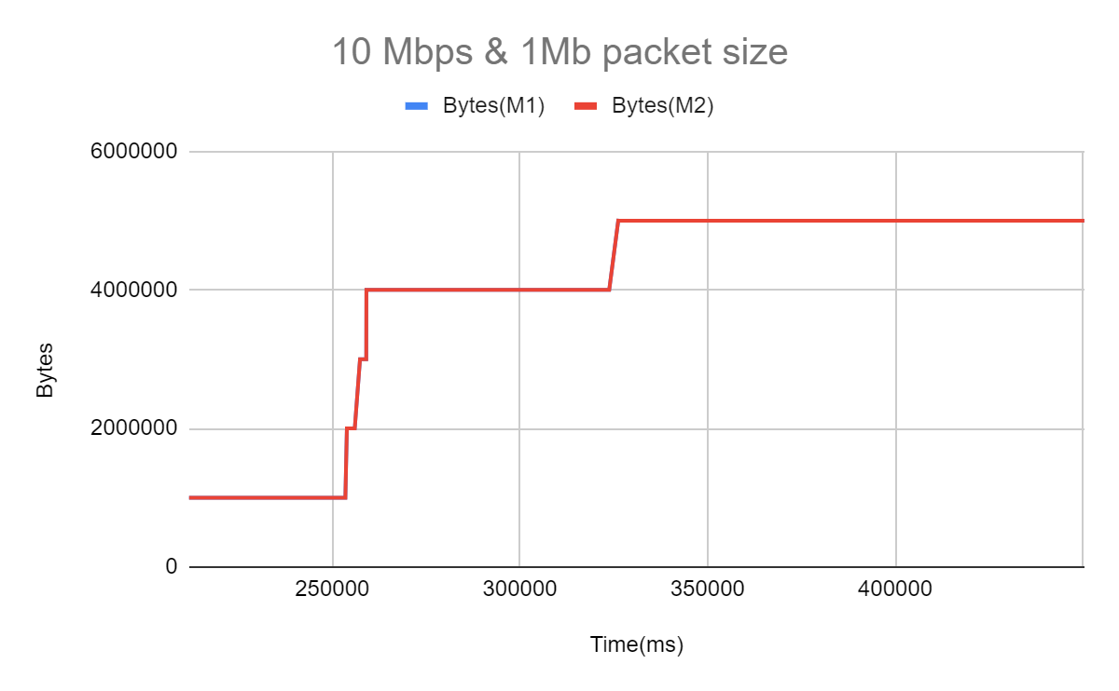

Figure 8. 10Mbps & 1Mb packet size

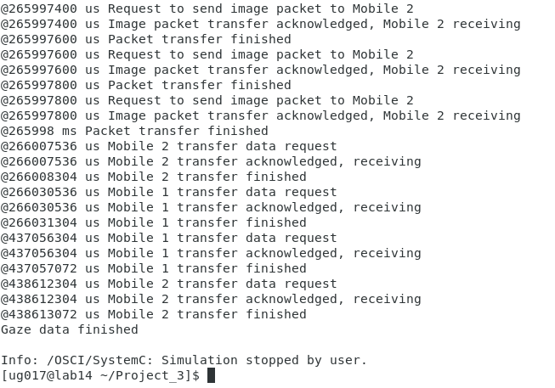

Figure 9. Sample simulation output of handshakes